Old clay brick
Where can use: | Exterior wall and interior wall
For what usage: | Antique clay bricks are used for wall decoration
Material: | Natural clay materials
Applying place: | Apartment,Hospital,University,Railway Station,Mall,Hotel,etc
Extrude way: | Antique clay bricks are from molded
Feature: | Acid-resistant,Antibacterial,Heat Insulation,Non-slip,Firebrick,Wear-resistant
Colors: | Red, white, grey
Packaging | Cartons box with strong wood pallets.
Size(L*W*H): | 240*55*20mm or cut according to your need

Our company
Cangzhou Shiyi building materials Co., Ltd. is engaged in the production of old bricks.We have our own factories and warehouses. we have hundreds of years old brick sliced and sold at home and abroad. Old bricks are natural handmade products, which are free from pollution and relieve the pressure of modern environmental protection. It also helps to inherit excellent traditional culture and traditional crafts.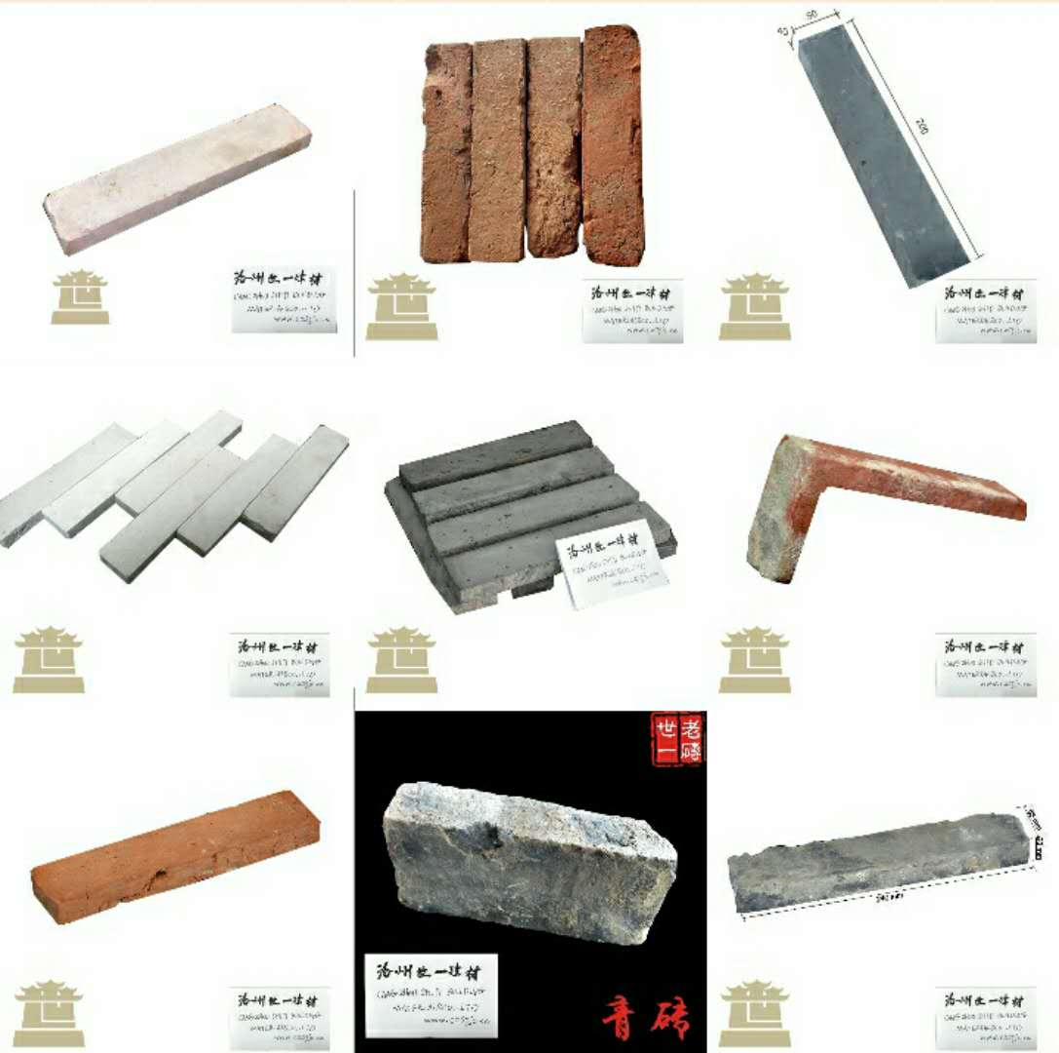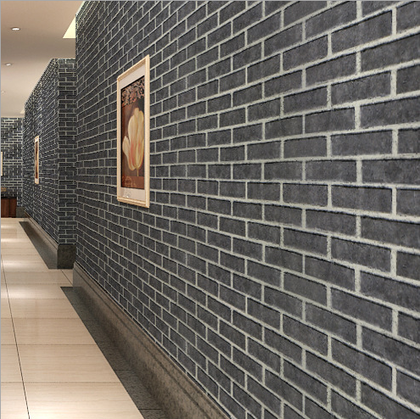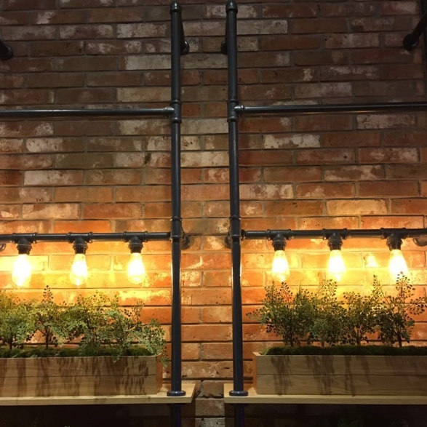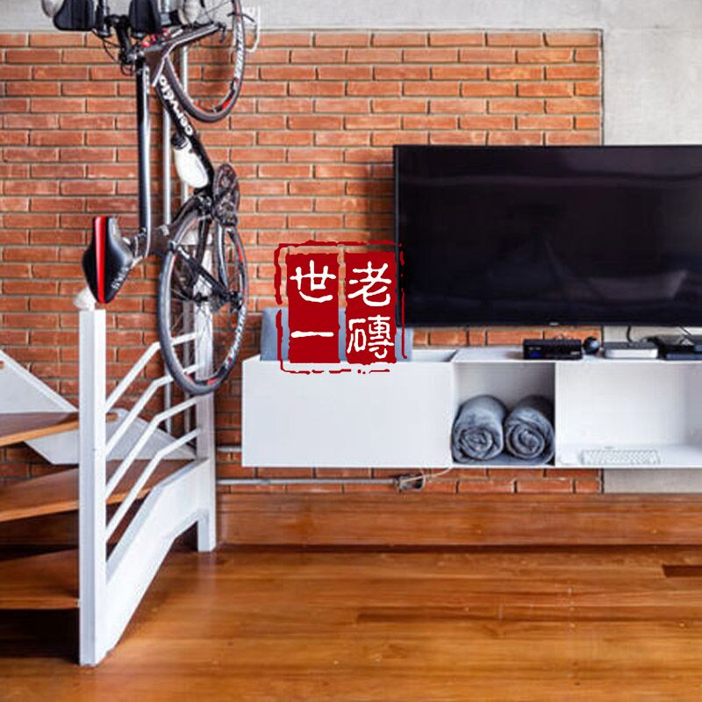
Why choose us?
1. Factory supply, professional manufacturer
2. Best quality control any time
4. Delivery in time
5. Export package protect goods safely
6. Good after sale service guarantee

Feature
1.strong frost resistance
2.low water absorption less than 6%
3.durable, long life time about 50 years
4.elegant, full of Chinese classical style feeling, but not lack of modern feeling
5.factory direct sale, save costs for your wall
6.fast and timely delivery, efficient stock

Our package
60pieces/carton 0.5kg/piece
Packing is on pallet or carton as the pictures, we also can pack according to your reply

